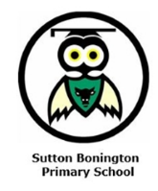
Year 6 Newsletter
Summer Term 2026

Dear Parents and Carers
Welcome back! I hope you all had a lovely Easter holiday. This is definitely going to be an eventful but exciting term for Year 6 and their final one at Sutton Bonington!
Topic
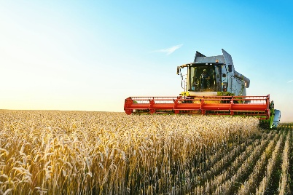
In Summer 1, our Geography topic will be ‘What’s it like in South America?’ Within this topic, your child will identify different countries which make up South America, explore human and physical features of the region and investigate Chile as a case study to explore what makes South America different to Europe. We will also focus on tourism.
In Spring 2, we will have a History based topic answering ‘What was Britain’s involvement in the slave trade?’ Within this topic, we will explore: what is the slave trade, how Britain was involved, what effect it had and how it ended. We will also discuss the relevance of how it is influential today.
In Science, we will look at ‘Electricity’ in Summer 1. Within this topic, we will look at why we use electricity and how it is generated. We will discover series circuits and simple circuits and carry out investigations linked with these and finally design a child’s night light using our new knowledge. In Summer 2, we will finish off with ‘Circulation and Lifestyle’.
SATs Week
As you are aware, SATs week will commence on Monday 11th May. Below are the dates and papers for your information.
Monday 11th May: English grammar, punctuation and spelling papers 1 and 2
Tuesday 12th May: English reading paper
Wednesday 13th May: Mathematics Paper 1: Arithmetic and Paper 2: Reasoning
Thursday 14th May: Mathematics Paper 3: Reasoning
PGL
Final details are currently being confirmed for our PGL trip on Sunday 7th-Wednesday 10th June. We will hold a PGL information evening in due course which will share details of the trip and what you need to bring.
Things to Remember
Children should bring in their book bag, water bottle and lunch box. Water bottles should be brought in for use throughout the day. Please make sure these are filled with water and clearly labelled. Also, please can clothing be labelled to reduce the chances of items getting lost. Finally, the SATs Breakfast Club will continue for the first four Tuesdays at 8:00am with our final session on Tuesday 5th May.
PE Days
In Summer 1, Class 6’s PE days will change to be on a Monday & Thursday with myself. Please can children come in their PE kits. In Summer 2, they will have forest school on Tuesday afternoons and I will share P.E days nearer the time.
Reading Books
As per the homework grid, children are expected to read a minimum of three times a week for at least 10 minutes. Please record these in their reading diary or they can do this themselves.
Homework
Thank you for the participation with the spring term grids. Children are expected to continue working on the tasks in the half-termly homework grid, which contains tasks for reading, maths, spellings and curriculum. Your child should be using TT Rock Stars and Doodle Maths on alternate weeks and both sites are checked regularly for engagement from each child. As mentioned at parents evening, any revision you can be doing with your child at home for SATs would be greatly appreciated and very beneficial to preparing them for the week and hopefully feeling more at ease. I will continue sending optional homework until SATS.
Values

We will be focusing on showing HONESTY in the first half term and demonstrating CURIOSITY in the second half term. We will cover this through assemblies, PSHE lessons and through everyday aspects of school life. Please ask your child how they have been able to show honesty and curiosity at school and at home.

If you have any questions or worries, please do not hesitate to come and speak to me in school.
Best wishes,
Mrs Welstead

