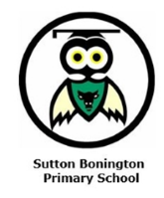
Year 6 Newsletter
Spring Term 2026
Dear Parents and Carers,

Welcome back! Happy new year to you all! We are looking forward to an exciting Spring Term. This term is packed with engaging topics and important learning opportunities.
In spring 1, our history topic will be, “How did World War Two affect the lives of everyday people?” We will explore the significance of World War Two including: How did Britain prepare for war, how it affected everyday lives, and who were some of the significant individuals including that of Anne Frank. We also have a trip booked to the Holocaust museum in February which will be fantastic and insightful!
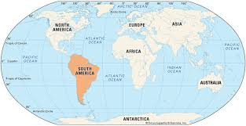
In spring 2, our geography topic will focus on South America, looking at both physical and human geography aspects. Children will explore features of South America using information about its climate, location and important landmarks.
In Science, we will look at ‘Evolution and Inheritance’ for the full term. Within this topic, we will look at what fossils tell us and investigate variation, inheritance and adaptation. Your child will study why animals have adaptations and move on to discovering natural selection and the theory of evolution. Finally, they will explain why animals become extinct and how we can save endangered animals.
Things to Remember
Each day could children bring in their book bag/backpack containing their reading book, water bottle and lunch box. Water bottles should be brought in for use throughout the day. Please make sure these are filled with water and clearly labelled. Also, please can clothing be labelled to reduce the chances of items getting lost.
PE Days
Class 6’s PE days will be on a Tuesday, with our sports coach, and Friday with myself. Please can children come in their PE kits and make sure all items are clearly labelled.
Reading Books
As per the homework grid, children are expected to read a minimum of three times a week for at least 10 minutes. Please record these in their reading diary or they can do this themselves.
Homework
Children should complete their weekly homework grid tasks which include weekly spelling and maths tasks (important revision for SATs) and a fortnightly topic focussed task.
SATs booster session
The SATs booster class will start on Tuesday 6th January and continue every Tuesday. Children should arrive at school at 8am and enter through the main gate to the Year 6 classroom.


Values
This term we will be focusing on showing PRIDE in the first half term and on demonstrating RESILIENCE in the second half term. We will cover this through assemblies, PSHE lessons and through everyday aspects of school life. Please ask your child how they have been able to show pride and resilience at school and at home.
If you have any questions or worries, please do not hesitate to come and speak to me in school.
Best wishes,
Mrs Welstead

