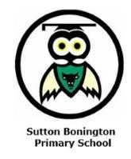
Year 1 Newsletter
Summer Term 2026

Dear Parents and Carers,
I hope you all had a wonderful Easter break and a warm welcome back! I am looking forwards to the summer term as there are lots of fun activities that will be happening this term.

Topic
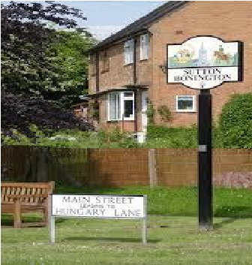
This half term our learning will be based around the question ‘Would you prefer to live somewhere hot or cold? Please see the attached knowledge organiser for further information about what they will be learning.
Summer 2 term our project will be based on ‘What was our school like in the past’. During this term we will be visiting a real Victorian classroom and comparing Victorian classroom to our classroom today. Please see the knowledge organiser for further information about what the children will be learning.
Our science work focuses on ‘The season of Spring and Summer’. The children will be focusing on types of weather that are associated with Spring and Summer also how the day length varies in different seasons.
For Design and Technology, the children will be making puppets. We will be learning about different joining techniques. The final skill will be to join the puppet by sewing it together.

Things to Remember
Wherever possible, please can the children bring one bag to school, preferably the green Sutton Bonington book bags. We have limited space within the class for rucksacks. The children need to bring their reading diary and reading practice book with them each day, a named water bottle and an additional healthy snack for afternoon break if you feel they need one. Fruit is provided by school for morning break.

P.E Days
This term P.E will be taught by a coach on Tuesday and Thursday afternoon. Children will need to come to school already wearing their PE kit on this day and will remain in their kit until home time.

Reading Books
Children will be bringing home a reading practice book linked to our phonics scheme and a reading record. Please record in their diary each time they have read the reading practice book (we suggest a minimum of three times a week) by noting the date, title and a brief comment. They will be changed once a week, usually on a Thursday. All children will be heard read at least once a week as part of their phonics sessions.
On Friday your child should have also brought home a ‘reading for pleasure’ book that they have chosen from the library. These will be changed every Friday, so this only needs to be brought to school on this day.
Homework
Please see the grid that accompanies this newsletter regarding homework this half term.

Values
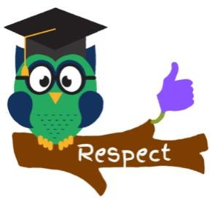
This term we will be focusing on showing HONESTY in the first half term and on demonstrating CURIOSITY in the second half term. We will cover this through assemblies, PSHE lessons and through everyday aspects of school life. Please ask your child how they have been able to show honesty and curiosity at school and at home.
If you have any questions or worries, please do not hesitate to come and speak to me in school.
Best wishes,
Ms Patel

