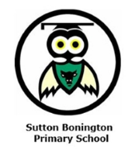**Reception Class Newsletter**

**Spring Term 2025**

Dear Parents and Carers,

Happy New Year to you all and a warm welcome back! We can’t believe we are already a third of the way through your child’s time in Reception. The children have enjoyed being back together this week and have started settling back into the school routines.

**Topic**

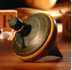This half term our learning will be based around the question ‘What was it like in the past?’ Your child will be learning about changes since they were babies. They will find out about what life was like when some of their grandparents were children. The children will explore how everyday objects, such as clothes, toys and vehicles have changed as well as other things like the role of the King. Children will also learn about fairy tales, the seasons and why we might wear special clothes at different times of the year. Please see the attached sheet for further information about the key vocabulary and knowledge we hope the children will gain by the end of this half term. As part of their homework, we would again appreciate you looking at this sheet with your child to help consolidate their learning.

After half term your child’s learning will be based around the question ‘Where does our food come from?’ Children will take part in practical activities to explore this and will learn what seeds and plants need to grow. They will explore what constitutes a healthy lifestyle, including eating fruit and vegetables, exercise and teeth brushing. They will find out about life on a farm and about baby animals. We will be organising a trip to a farm during this half term and will let you know further details about this as soon as possible. The children will learn about the changes that happen in spring, including the weather and living things. Springtime festivals will also be explored.

**Milk**

Children under 4 will continue to receive free milk through the ‘Cool milk’ scheme. From their 5th birthday, children may no longer be eligible for free milk and you will need to make a payment a few weeks before their birthday in order for them to continue to receive it. You will need to visit <https://www.coolmilk.com/parents/> to do this. If your child drinks a milk alternative, please continue to send them in with it on a Monday with enough for the week.

**PE Days**

This term, P.E will be with a specialist coach on Tuesday afternoons and with Mrs Hopkin on Thursday afternoons. Children will need to bring their PE kit in a clearly labelled bag on Thursdays and can come dressed in their kit on a Tuesday.

**Reading Books**

We will continue to change reading books on a Friday. Please continue to hear your child read regularly and record how they got on with the book in their reading diary. If you have come across any school reading scheme books over the holidays, please send them back into school as soon as possible, as we only have a few copies of each book that are all needed when reading with groups of children at the same time.

**Homework**

Please see the separate sheet attached regarding the Reception class homework activities for the Spring 1 term. Please continue to use Tapestry to share your child’s achievements and home learning.

**Values**

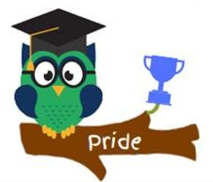This half term our whole school focus will be on showing PRIDE and next half term we will focus on the value of RESILIENCE. We will cover these through assemblies, PSHE lessons and through everyday aspects of school life. Please ask your child about achievements they have been proud of, as well as ask them how they are able to show pride at school and at home.

If you have any questions or concerns, please do not hesitate to come and speak to me in school.

Best wishes,

Miss Carte.